RSHS

PHYSICS
UNIT 3 Semester One 2020

Marking Key

Marking keys outline the expectations of examination responses. They help to ensure a consistent interpretation of the criteria that guide the awarding of marks.

Section One: Short response | 30 % (54 Marks)
______________________________________________________________________________

Question 1 (5 marks)

A single square wire loop of length 5.00 cm is placed near a long straight wire carrying a constant current of 15.4 A as shown in the diagram below. The center of the loop is located 6.00 cm away from the wire. The loop then rotates 90.0° uniformly along the axis shown with the resistor moving out of the page in a time of 1.00 x10⁻² s. Calculate the average magnitude of the induced EMF while the loop rotates. Provide your answer in µV in the space provided below.

Resistor
I 6.00 cm

Description | Marks
$B$ = $\frac{μ_{0}I}{2πr}$ = $\frac{4π ×10^{-7}(15.4)}{2π(0.06)}$ = = 5.13 x10⁻ T | 1-2
$ε=\frac{-n∆ϕ}{∆t}= \frac{-1(0-5.13 x10^{-5}×\left(0.05^{2}\right))}{0.01}$ = 1.28 x10⁻⁵ V | 1-2
= 12.8 µV | 1
Total | 5

Common Mistakes:
- Not using r = 0.06 m for an average value of B
- Using $ε=vBl$ which gives max V, not average, and not always finding v correctly based on t in question being for a 90 deg turn, not a full rotation.
- Trying to use $ε=4BANf$ as a shortcut but not working out f correctly. Details in question supported using Faraday’s law as written in Formula and Data Booklet.

Question 2 (4 marks)

Consider the AC generator model below consisting of a 0.0100 m² coil of 100 turns placed completely in a uniform magnetic field of 0.150 T. Calculate the magnitude of the V_{RMS} generated if the coil turns at a rate of 30.0 Hz.
S
N

Description | Marks
$ε$_{max} = 2$π$BANf = $2π\left(0.15\right)\left(0.01\right)\left(100\right)30=28.27 V$ | 1-2
$ε$_{RMS}= $\frac{εMax}{\sqrt{2}}= \frac{28.27}{\sqrt{2}}$ = 20.0 V | 1-2
Total | 4

Question 3 (3 marks)

A conventional current of 30.0 A flows up a 5.00 m vertical power pole. The power pole is located in Perth where the magnetic field is 5.50 x 10⁻⁵ T North at 66.0° to the horizontal. Calculate the force acting on the power line due to the Earth’s magnetic field.

B

I

66.0°

Description | Marks
F = B$⊥$IL
F = 5.50x10⁻⁵cos(66.0)(30)(5) = 3.36 x10⁻³ N ignoring components = 0 marks | 1-2
West Did not accept “into the page” | 1
Total | 3

Common Mistakes:
- using sin66, instead of cos66. Must find perpendicular component of B to I.
- No direction or “into page”. “Into page” is correct, but question gives a bearing (field is north) so answer must be related to the question info.

Question 4 (3 marks)

Calculate the gravitational force of attraction the Moon exerts on the Earth

Description | Marks
$ΣF=\frac{Gm_{1}m_{2}}{r^{2}}$ | 1
= (6.67x10⁻¹¹)(5.97x10²⁴)(7.35x10²²)  (3.84x10⁸)² | 1
= 1.98 x10²⁰ N towards moon | 1
Total | 3

Common Mistakes:
- Adding in r_{earth} and r_{moon}. All data in formula booklet is between centers of mass already.
- Finding g instead of force
- Not squaring the distance after inserting values to the formula
Question 5 (5 marks)

Two positive charges are 12.0 cm apart as shown. Calculate the distance from q₁ where the net force on a test charge would be zero.

r = 12.0 cm
+
+

x r-x
q₁ = 2.00 µC q₂ = 4.00 µC

Description | Marks
F_{q1} = F_{q2} | 1
$$\frac{1}{4πε}.\frac{Qq1}{{(x)}^{2}}= \frac{1}{4πε}.\frac{Qq2}{{(r-x)}^{2}}$$ | 1-2
$$\frac{q1}{{(x)}^{2}}= \frac{q2}{{(r-x)}^{2}}$$  $$\frac{q1}{q2}= \frac{x^{2}}{(r-{x)}^{2}}$$  $\sqrt{\frac{1}{2}}= \frac{x}{(r-x)}$ $\sqrt{\frac{1}{2}}(r-x)$ = x  $\sqrt{\frac{1}{2}}r$ = x + $\sqrt{\frac{1}{2}}(x)$ x = $\frac{\sqrt{\frac{1}{2}}(12)}{1+\sqrt{\frac{1}{2}}}$  r = 4.97 cm | 1-2
Total | 5

Common Mistakes:
- Calculating the force between q1 and q2 (no marks for this approach)
- Not assigning an arbitrary value Q for the test charge (setting Q = 1.6×10⁻¹⁹ works but is not necessary/ideal)
- Forgetting to square the distances after assigning values
- Stating the force between q1 and q2 is 0 (no marks for this approach)
- Basic algebra manipulation. Despite an incorrect approach, suggesting:
$$0=k\frac{q_{1}q_{2}}{r^{2}} ∴r^{2}=kq_{1}q_{2}$$
Exemplifies a lack of understanding of the assumed knowledge of algebra required for Physics Unit 1-2 and 3-4.
Question 6 (8 marks)

A box of mass 15.0 kg sits 0.820 m up an incline of 25.0° as shown in the diagram. A rope parallel to
the incline keeps the box at rest.

(a) Calculate the tension of the rope (ignoring any static friction) (3 marks)

25.0°
0.820 m

Description | Marks
∑F = 0, therefore T = mgsin$θ$ | 1
T = mgsin$θ$  = (15.0)(9.8)sin(25)  = 62.1 N | 1-2
Total | 3

(b) Calculate the frictional force that acts on the box parallel to the incline to oppose the motion.
(5 marks)

Description | Marks
s = ut +1/2at²  $a=2s/t^{2}$  = 2(-0.820)  0.800²  = -2.56 ms⁻² | 1-2
∑F = ma =F_{f} + mgsin$θ$ | 1
(15)(-2.56) = -62.1 + F_{F}  F_{F} = -38.4 + 62.1  = 23.7 N up the incline. | 1-2
Total | 5

Common Mistakes:
- Determining $a$ via $v=s/t$ then $v=u+at$. $v=/st$ gives the average velocity. $v=u+at$ requires the final velocity. Don’t use $v=s/t$ any time $a≠0$ UNLESS asked specifically for the average.
- Assuming $a=0$ and finding friction = force down slope due to gravity

Question 7 (4 marks)

The World Strongman “Hercules Hold” involves a person holding on to two large pillars for as long as possible. In the diagram below, two 1250 kg pillars are held stationary at an angle of 15.0° by two horizontal steel chains inserted 1.35 m from the base. The pillars are of uniform mass and 3.20 m tall. Calculate the tension in each of the steel cables.

15.0°
1.35 m
1.40 m
15.0°
1250 kg
1250 kg

Description | Marks
$$Στ=0 τ=rFsinθ$$  $$cwm = acwm$$  Taking pivot about base of pillar | 1
T x 1.4 = $\frac{3.2}{2}\left(1250×9.8\right)\sin\left(15\right)$  T = $\frac{\frac{3.2}{2}\left(1250×9.8\right)sin⁡(15)}{1.4}$ = 3.62x10³ N | 1-3
Total | 4

Common Mistakes:
- The 1.35 m dimension is useless information. It is not measuring from the pivot point.
- Calculating a different tension for each rope (see previous point about 1.35 m dimension)
- Not finding appropriate perpendicular force/distance values. For example, multiplying 1.4 m by sin or cos when 1.4 m is already the perpendicular distance to the tension.

Question 8 (6 marks)

(a) Calculate the ‘ideal speed’ that the car can travel at without relying on friction. (4 marks)

$$θ$$  N  mg  ΣF = F_{c} | 1
$$tanθ=\frac{Fc}{W}=\frac{{mv^{2}}/r}{mg}$$  =$\frac{v^{2}}{rg}$  $v^{2}$= rgtan$θ$ | 1-2
v = $\sqrt{171(9.8)tan⁡(13.4)}$  = 20.0 m s⁻¹ | 1

Common Mistake: Not setting up a suitable vector diagram/mixing up the diagram with an inclined plane problem.

(b) On both of the diagrams below, draw a vector diagram showing all the forces including friction (F_{f})that must act on the cars in order for them to travel in horizontal circular motion. The net force may be drawn as a dashed line and the normal force is already drawn for you.
(2 marks)
W
F_{F}
ΣF
F_{N}
13.4°

Description | Marks
Correctly drawn vector diagram (not free body diagram) | 1-2
Total | 2
Deduct marks if:
F_{F} is wrong direction or not parallel to incline
ΣF is not horizontal
Common Mistakes:
- Drawing FBD instead of vector diagram
- Adding $F{}_{c}$ to the diagram in addition to the net force. These are the same thing – Fc is not a physical force like friction, weight, tension. Physical forces combine to produce the F_{c}/net force.
- Breaking Physics by not drawing friction along slope or not having net force act horizontally
Question 9 (8 marks)

A motorcycle and riders of combined mass of 355 kg is travelling over the undulating road as shown in the diagram below. The radius of curvature at points A and B are shown.



A
13.0 m s⁻¹
40.0 m
60.0 m
B

(a) Calculate the force that the motorcycle exerts on the road at point A.
(4 marks)

Description | Marks
$ΣFy=Fc=\frac{mv^{2}}{r}=W+F_{N}$ | 1
- $\frac{(355){13.0}^{2}}{40}$ = (355 x -9.8) +F_{N} | 1
F_{N} = - 1500 + 3479  = 1979 N  therefore, Bike exerts 1.98 kN | 1
downwards | 1
Total | 4

(b) If the occupants of the motorcycle feel 1.35 times heavier (than their regular weight) at point B, calculate the speed the motorcycle is travelling at point B.
(4 marks)

Description | Marks
F_{N} = 1.35x (355 x 9.8)  = 4697 N upwards | 1
$ΣFy=Fc=\frac{mv^{2}}{r}=W+F_{N}$ | 1
- $\frac{(355)v^{2}}{60}$ = (355 x -9.8) + 4697 = 1218N  v² = $\frac{1218(60)}{355}$ | 1
v = 14.3 m s⁻¹ | 1
Total | 4

Question 10 (5 marks)

A power station generates electric power at a rate of 2.00 x 10² MW. The power is transmitted along a 40.0 km long transmission line to a transformer at voltage of 220 kV. The line has a resistance rating of 0.150 Ω km⁻¹. Calculate the voltage delivered to the primary coil of the transformer at the end of this transmission line. Show working.
(5 marks)

Power Station
P = 200 MW
Transformer
Transmission Line

$$R_{T}=40 ×0.15=6.00 Ω$$ | 1 mark
$I_{T}= \frac{P_{T}}{V_{T}}= \frac{200 × {10}^{6}}{220 × {10}^{3}}$ $$I_{T}=909 A$$ | 1-2 mark
$$V_{D}=220000-909 ×6$$  $$V_{D}=2.15 × {10}^{5} V$$ | 1-2 mark

Question 11 (3 marks)

The diagram below models an electromagnetic wave.

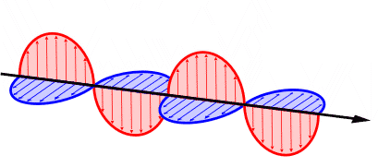
velocity
Magnetic (or Electric)
Electric (or Magnetic)

Describe the relationship between the plane of the oscillating fields and direction of propagation (velocity) of the wave. Label the diagram to assist with your description.

Field oscillations are perpendicular 1 | 1
Velocity is perpendicular to oscillation planes | 1
Suitable labels for both fields and the velocity | 1

End of Section One

Section Two: Problem-solving | 50 % (90 Marks)
________________________________________________________________________________

Question 12 (13 marks)
+
-
e⁻

(a) In the boxes to the left of the plates, state the charge that plates must have in order to deflect the electron (1 mark)

(b) On the diagram, draw the electric field produced by the horizontal plates only. (1 mark)

Description | Marks
See diagram above. | 1-2
Pay 1 if charge wrong but field is consistent with diagram Total | 2

(c) Calculate the speed of the electron as it enters the horizontal plates. (3 marks)

Description | Marks
W = qV = Ef – Ei = ½mv² – ½mu² | 1
qV = ½mv², v = $\sqrt{\frac{2qV}{m}}$  =$\sqrt{\frac{2(1.6×10^{-19})(1500)}{9.11×10^{-31}}}$ | 1
= 2.30 x10⁷ m s⁻¹ | 1
Total | 3

(d) Calculate the acceleration of the electron while it is within the horizontal plates. (3 marks)
Question deleted

(e) Calculate the angle to the horizontal that the electron will be travelling at as it leaves the field. (If you could not complete part (c), use a speed of 2.00 x10⁷ ms⁻¹). (5 marks)

Question deleted

Description | Marks
t = $\frac{s_{x}}{u_{x}}= \frac{0.16}{2.30 ×10^{7}}=6.95×10^{-9} s$ | 1
v_{y} = u + at  = (4.39 x10¹⁴ x 6.95 x10⁻⁹) | 1
= 3.05 x10⁶ m s⁻¹ | 1
$θ=tan^{-1}\left(\frac{3.05×10^{6}}{2.30 ×10^{7}}\right)$ | 1
= 7.55 ° | 1
Total | 5

Question 13 (16 marks)
A 50.0 g mass is connected to 45.0 cm long piece of string which is fixed at one end. Hence, it is able to act as a pendulum. The string has a breaking tension of 0.700 N.
The mass is raised to a height ‘h’ (point A) and released. At point B, the string is vertical and just reaches its breaking tension of 0.700 N – hence, it snaps. This situation is illustrated in the diagram below.
50.0 g
45 .0 cm
h

A

B

- Given that string only just reaches its breaking tension of 0.700 N at point B, calculate the instantaneous speed of the 50.0g mass at this point. Show working.
(5 marks)

$$T= \frac{{mv}^{2}}{r}+mg$$ | 1 mark
$$0.700= \frac{{0.050v}^{2}}{0.45}+0.05 ×9.80$$ | 1-2 marks
$$v^{2}=1.89$$ | 1 mark
$$∴v=1.37 {ms}^{-1}$$ | 1 mark
If only error sign of weight and working clear pay 2
If weight ignored them MAX of 1 assuming clear working

- Hence, calculate the height (h) at which the mass was released.
[If you were unable to calculate an answer for part a), use a speed of 1.40 ms⁻¹ at point B]
(4 marks)

$$E_{p} \left(A\right)= E_{k} \left(B\right)$$ | 1 mark
$$mgh= \frac{1}{2} {mv}^{2}; ∴h= \frac{v^{2}}{2g}$$ | 1 mark
$$h= \frac{{1.37}^{2}}{2 ×9.80}$$ | 1 mark
$$∴h=0.0964 m$$ | 1 mark
- 1 if not 3 sf

The string snaps at point B; hence, the 50.0g mass becomes a projectile. For the questions that follow the diagram below, assume air resistance is negligible.

h

x
1.00 m
B
A

1.37 ms⁻¹

- On the diagram above, draw a vector representing the instantaneous velocity of the 50.0 g mass at B. Label this vector with the magnitude of this velocity.
(2 marks)

Horizontal arrow to the right.(-1 if any other arrow drawn) | 1 mark
Magnitude of velocity is provided with units. | 1 mark

- Calculate the value of ‘x’ – the horizontal range of the projectile. Show all working.
(5 marks)
$$s=ut+ \frac{1}{2} {at}^{2};u=0 {ms}^{-1};a= 9.80 {ms}^{-2};s=1.00m;t= ?$$ | 1 mark
$$1.00=0 ×t+0.5 ×9.80 × t^{2}$$ | 1 mark
$$t= \sqrt{\frac{1.00}{4.90}} =0.452 s$$ | 1 mark
$$s_{h}= v_{h} ×t=1.37 ×0.452$$ | 1 mark
$$=0.619 m$$ | 1 mark

Question 14 (16 marks)

A 4.00 m long 10.0 kg ladder of uniform mass is resting against a wall such that its legs are 1.70 m away from the wall.

(a) Calculate the Reaction Force at the wall. (5 marks)

Description | Marks
$θ=sin^{-1}\left(\frac{1.7}{4}\right)$ = 25.2° Or finding angle at base = 64.8⁰ | 1
$$Στ=0 τ=rFsinθ$$  $$cwm = acwm$$  Taking pivot about base of ladder | 1
$$\frac{4}{2}\left(10.0×9.8\right)\sin\left(25.2\right)=4\left(F_{R}\right)\cos{(25.2)}$$  $F_{R}=\frac{83.5}{4sin(64.8)}$= 23.1 N | 1-3
Total | 5

Common Mistakes: Not finding suitable perpendicular distances (misuse of sin/cos)

(b) Calculate the magnitude and direction of the total reaction force from the ground. This total reaction is the sum of Friction and Normal Force acting at this point. (4 marks)

Description | Marks
$ΣFy=0$= W_{ladder} + F_{RY}  F_{RY} = -(10.0 x -9.8)  = +98.0 N | 1
$ΣFx=0$= F_{F} + F_{RX}  F_{F} = 23.1 N | 1
F_{R} = $\sqrt{98.0^{2}+23.1^{2}}$  = 101 N  $$θ=tan^{-1}\left(\frac{101}{23.1}\right)$$  = 77.1° | 1
F_{R} = 101 N Towards the wall 77.1° above horizontal | 1
Total | 4

Common Mistakes:
- Ignoring two dimensional nature of problem, adding friction and normal as scalars
- Appling more sin/cos to friction and/or reaction despite already being horizontal and vertical aligned forces respectively.
(c) Calculate the maximum distance along the ladder from the base that the worker could stand before the ladder begins to slip. (4 marks)

Description | Marks
Set F_{F} = F_{R} = 200 N  $$Στ=0 τ=rFsinθ$$  $$cwm = acwm$$  Taking pivot about base of ladder | 1
$$\frac{4}{2}\left(10.0×9.8\right)\sin\left(25.2\right)+r\left(80.0 ×9.80\right)sin25.2=4\left(200\right)cos⁡(25.2)$$ | 1
$$r=\frac{723.86-83.45}{80.0×9.80sin⁡(25.2)}$$ | 1
= 1.92 m | 1
Total | 4

Common Mistakes:
- Not converting 200 N friction force into a suitable torque from the base of the ladder
- Not finding suitable perpendicular distances (misuse of sin/cos) (applied follow through marks from part a)
- Finding $r$ but the perpendicular value. Need to find length along the ladder.

(d) On the graph below, sketch on the y axis the value of the frictional force, as a function of the distance on the x axis. Indicate where the worker would be along the ladder before it slipped. Identify this point at which the ladder will slip in your sketch. A spare graph is provided on the end of this Question/Answer booklet. (3 marks)

Description | Marks
Point of slip identified on graph. (allow error carried forwards from (c) | 1
Axes correctly labelled and scaled appropriately. | 1
Y-int is value calculated from part (a)  Graph should also be linear but an otherwise well detailed graph can accept a curve from y-int to slip point | 1
Total | 3
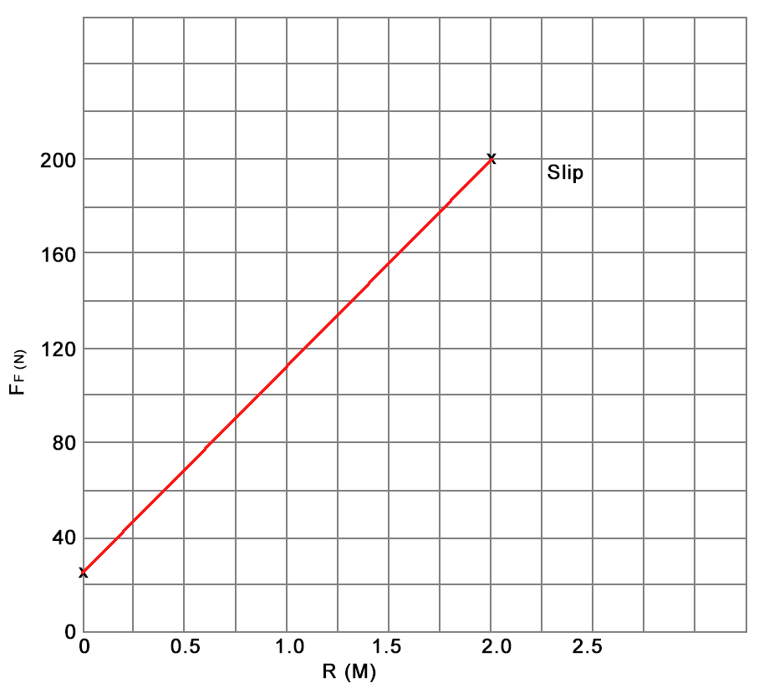

Common Mistakes:
- Not labelling slip point as instructed
- Not adding a scale. Questions that lack data don’t require values but this question had sufficient data and was asking to identify points of interest.

Question 15 (16 marks)
23.0 cm
45.0 cm
During a Physics experiment investigating horizontal circular motion, a student is swinging a 150 g mass in a horizontal circle of radius 23.0 cm. the mass is attached to a string that is 45.0 cm in length.

θ

- Draw a vector diagram showing the forces acting on the mass and the net force that results.
(3 marks)

T
W or mg F_{g}

F_{NET} or F_{c}

All three forces correctly identified and labelled. | 1 mark
Direction of forces correctly identified. | 1 mark
Right angled triangle drawn. | 1 mark

- Use the dimensions of the string and the radius of the path to perform a calculation that shows that the value of ‘θ’ is about 30°.
(3 marks)

Position of $θ$ in question paper was incorrect. All answers accepted for the determination of a $θ$ value either as shown in paper, acute angle at top of triangle or acute angle at bottom of triangle/ reducing angle by measuring from a horizontal guide line.  $$\sin{θ}= \frac{0.23}{0.45}=0.511$$ | 1-2 marks
$$∴ θ=30.7°$$ | 1 mark

- Hence, calculate the tension in the string.
[If you could not calculate a value for ‘θ’, use 30°]
(4 marks)

Working MUST reflect student’s choice of $θ$ location from part b  $$\cos{θ}= \frac{W}{T}$$ | 1 mark
$$\cos{30.7°}= \frac{1.47}{T}$$ | 1 mark
$$∴T= \frac{1.47}{\cos{30.7°}}$$ | 1 mark
$T= 1.71 N$ (1.70) | 1 mark

- Calculate the period (T) of revolution for the mass.
(6 marks)

$$\frac{F_{c}}{T}= \sin{30.7°}; ∴ F_{c}=T\sin{30.7°}$$ | 1 mark
$$F_{c}=1.71 × \sin{30.7°}=0.873 N$$ | 1 mark
$$F_{c}= \frac{{mv}^{2}}{r}; ∴v= \sqrt{\frac{F_{c}r}{m}}$$ | 1 mark
$$v= \sqrt{\frac{0.873 ×0.23}{0.150}}=1.16 {ms}^{-1}$$ | 1 mark
$$v= \frac{2πr}{T}; ∴T = \frac{2πr}{v}$$ | 1 mark
$$T = \frac{2π ×0.23}{1.16}=1.25 s$$ | 1 mark

Common Mistakes:
- Poor trigonometry, mixing up sin, cos and tan or whether a side was a hypotenuse or smaller side.

Question 16 (12 marks)

(a) Indicate on the diagram the direction of the force on side AB. (1 mark)

Description | Marks
Arrow indicating the direction of the force on side AB | 1
B C
N
S

A D

Total | 2

(b) If the magnetic field has strength of 0.550 T and 2.00 A flows in the circuit, calculate the magnitude of force on side length AB. (2 marks)

Description | Marks
F = nBIL  = (1)(0.550)(2.00)(0.400) | 1
= 0.440 N | 1
Total | 2

(c) Calculate the maximum torque produced by the coil. (3 marks)

Description | Marks
$τ_{total}=2rF$ | 1
= 2(0.300/2)(0.440) | 1
= 0.132 N m clockwise | 1
Total | 3

(d) On the axis provided, sketch and label the force produced on the side AB as it is rotated though 360 degrees from the orientation shown in the diagram.
(2 marks)
F(N)

+0.44

90 180 270 360

- 0.44

Description | Marks
Sketch correct | 1
Label correct | 1
Total | 2

(e) On the axis below, sketch and label the torque produced on side AB as it is rotated through 360 degrees from the orientation shown. (2 marks)
$τ$ (Nm)

0.066

90 180 270 360
Description | Marks
Sketch correct | 1
Label correct | 1
Total | 2

(f) Sketch the net magnetic field produced by the magnets and the coil in the cross section below. Provide at least five field lines to demonstrate the net field. A spare diagram is provided on the end of this Question/Answer booklet. (2 marks)

X
N
S

Description | Marks
at least five field lines correctly drawn | 2
Total | 2

Question 17 (18 marks)

(a) On the circuit above, draw the direction of the conventional current in order to register a downward force. (1 mark)

Description |  |  | Marks
magnetic force (x10⁻² N) correct |  |  | 1
Total |  |  | 1
Current (A) | Mass (± 0.20 g) | Magnetic Force (x10⁻² N)
0.00 | zero (no reading) | 0.00
1.37 | 0.50 | 0.49 ± 0.2
1.87 | 0.70 | 0.69 ± 0.2
2.55 | 0.90 | 0.88 ± 0.2
5.37 | 1.84 | 1.80 ± 0.2
8.29 | 2.81 | 2.75 ± 0.2
11.45 | 3.98 | 3.90 ± 0.2

(b) Convert the reading of mass to weight and, hence, complete the final column in the table, including an absolute uncertainty for each reading.
(2 marks)

Description | Marks
magnetic force (x10⁻² N) correct | 1
Absolute uncertainties correct | 1
Total | 2

(c) On the graph, plot Magnetic Force vs Current including error bars. A spare grid is provided on the end of this Question/Answer booklet. If you need to use it, cross out this attempt and clearly indicate that you have redrawn it on the spare page.
(5 marks)

Description | Marks
Correct plotting of points | 1
Correct plotting of uncertainty bars | 1
Correct label of x and y axes | 1
Scale correct | 1
Line of best fit is drawn relevant to the uncertanties | 1
Total | 5

(d) Determine the gradient of the graph. (3 marks)

Description | Marks
Significant figures depends on decimal places used in fraction.
Construction lines drawn to line of best fit or points stated. Not from table. | 1
m = y₂ – y₁ = (3.4 – 2.0)x10⁻²  x₂ – x₁ 10.0 – 6.0 | 1
= 3.5 x10⁻³ N A⁻¹ Allow 3.3 – 3.7 | 1
Total | 3

Question 17 (continued)

(e) Use the gradient to determine the magnetic field strength between the two magnets.
(3 marks)

Description | Marks
Deduct 1 mark if sig figs from Q19(c) not used
F = nBIL F/n = nBl = 3.5 x10⁻³ | 1
B = 3.5 x10⁻³  1(0.02) | 1
= 0.175 T  (range from Q18(c) = 0.165 to 0.185) | 1
Total | 3

(f) Using your determined value for the magnetic field strength in part (d), calculate the Magnetic force acting on the wire if a conventional current of 10.0 A flows through the wire. (if you could not complete part (d), use B = 0.15 T). (4 marks)

Description | Marks
F = nBIL | 1
= 1(0.175)(10.0)(0.020) | 1
= 0.035 N | 1
Direction down 30.0° Right | 1
Total | 4

End of Section Two

Section Three: Comprehension | 20 % (36 Marks)

This section has two questions. You must answer both questions. Write your answers in the spaces provided.

When calculating numerical answers, show your working or reasoning clearly. Give final answers to three significant figures and include appropriate units where applicable.

When estimating numerical answers, show your working or reasoning clearly. Give final answers to a maximum of two significant figures and include appropriate units where applicable.

Supplementary pages for planning/continuing your answers to questions are provided at the end of this Question/Answer booklet. If you use these pages to continue an answer, indicate at the original answer where the answer is continued, i.e. give the page number.

Suggested working time: 30 minutes.

Question 18 (18 marks)

Sun-synchronous orbits (SSO)
Satellites in polar orbits travel around Earth from north to south rather than from west to east, passing roughly over Earth's poles. Satellites in a polar orbit do not have to pass the North and South Pole precisely; even a deviation within 20 degrees from a 90 degree inclination is still classed as a polar orbit. Polar orbits are also often low Earth orbits, with satellites at altitudes between 200 to 1000 km.

Venus is an almost perfectly spherical planet. Satellites in orbit around Venus maintain a constant orientation of their orbital plane with respect to distant stars. Figure 1 shows this, with the angle $θ$ between the orbital plane and the distant stars remaining constant throughout the Venus year.
Orbital plane
$$θ$$
To some distant star

$$θ$$
$$θ$$

$$θ$$

Figure 1 – Satellite of Venus

Most planets are not perfectly spherical. The Earth bulges at the Equator due to its rotation about its axis. The bulge of mass causes disturbances to the orbit of its satellites, causing orbital planes to rotate around the Earth’s rotational axis. The rotation of an orbital plane is called a ‘precession’ of the orbit. A special type of orbit precession is shown in Figure 2.

Planet orbit

The orbital plane precession (rotation) about the planet’s axis, relative to the distant stars

Figure 2 – SSO orbit

The special feature of this orbit is that the precession is in synch with the planet’s revolution around the Sun. The Earth revolves 360⁰ around the Sun in a year. When a satellites orbital plane also precesses 360⁰ in a year, this is referred to as a Sun-synchronous orbit (SSO). A SSO has the unique feature that it can pass over places on Earth at the same local time each day. For example, passing over Perth, Western Australia at 7:00 am, every day.

This serves a number of applications; for example, it means the satellite images can monitor an area by taking a series of images of a certain place across many days, weeks, months, or even years. Each image is taken under the same lighting conditions. Scientists use image series like these to investigate how weather patterns emerge, to help predict weather or storms; when monitoring emergencies like forest fires or flooding; or to accumulate data on long-term problems like deforestation or rising sea levels.

Often, satellites in SSO are synchronised so that they are in constant dawn or dusk (as shown in Figure 2) – this is because by constantly riding a sunset or sunrise, they will never have the Sun at an angle where the Earth shadows them. A satellite in a Sun-synchronous orbit would usually be at an altitude of between 600 to 800 km, completing several revolutions in an Earth day.

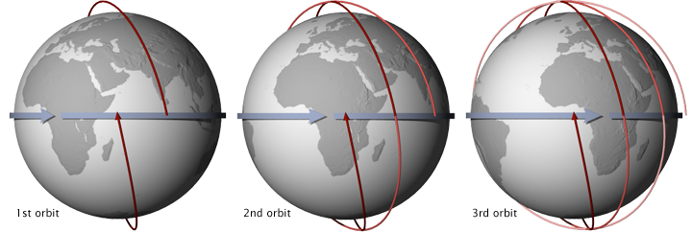

To achieve a SSO requires an orbital inclination (the angle between the orbital plane and the equator) that causes an orbital precession of 360⁰ a year. Factors such as the equatorial radius, the amount of bulge, the eccentricity of the orbit all play a part. For a circular orbit around the Earth, these factors can be simplified to the following relationship:

$$\cos{i}=-{\left(\frac{r}{1.235×{10}^{7}}\right)}^{\frac{7}{2}}$$

- $i$ is the angle of inclination (degrees)
- $r$ is the orbital distance (m)

- By referring to physical principles, explain why most planets have a bulge at their equator.
(4 marks)

This is due to the rotation of the planet 1
The mass around the equator requires a centripetal force to maintain its circular path around the axis. 1
If the gravitational force is not sufficiently strong, this mass is not pulled as close to the centre as mass near the poles, causing the bulge 1-2

- Calculate the rate of precession of a SSO in degrees per day.
(2 marks)

$precession rate =\frac{{360}^{0}}{365 days}={0.986}^{0} per day$ 1-2

- Show via calculation that a typical SSO satellite of Earth orbits several times a day.
(4 marks)

$T^{2}=\frac{4π^{2}}{GM} r^{3}$ (1)
$T^{2}=\frac{4π^{2}}{6.67×{10}^{-11}×5.97×{10}^{24}} {\left(6.37×{10}^{6}+700×{10}^{3}\right)}^{3}$ (accept between 600-800 km alt)
(1-2)
$T=5.919×{10}^{3} s$

$T=1.6 hours$ therefore several times within 24 hours (1)

- The article describes a SSO that is in constant dawn/dusk. Another type of SSO alternates between noon and midnight. Draw in the orbit of a noon/midnight SSO at each position of Earth in the diagram below. (2 marks)

Orbits are SSO (rotate with planet revolutions) 1

All orbits cover 1 noon/midnight

- Use the relationship given in the article for the following questions:

  - Calculate the orbital inclination for a SSO around Earth at an orbital distance of 7.27×10⁶ m.
(2 marks)
$\cos{i}=-{\left(\frac{r}{1.235×{10}^{7}}\right)}^{\frac{7}{2}}$

$\cos{i}=-{\left(\frac{7.27×{10}^{6}}{1.235×{10}^{7}}\right)}^{\frac{7}{2}}$ 1
$i={99.0}^{0}$ 1

  - Hence, describe whether this SSO would be classified as a polar orbit.
(2 marks)

Yes polar. 1
The inclination is within 20 degrees of a 90 degree inclination 1

  - Determine the theoretical maximum orbital distance for a SSO around Earth.
(2 marks)

1 mark for the correct angle and 1 mark for correct maximum distance
$\cos{i}=-{\left(\frac{r}{1.235×{10}^{7}}\right)}^{\frac{7}{2}}$ breaks down if $\frac{r}{1.235×{10}^{7}}>1$ (cos i = 1 ᶿ = 0 or 360° or 180°) 1
Hence the maximum distance is 1.235×10⁷ m 1
Question 19 (18 marks)

The Cavendish Experiment

The Cavendish Experiment was conducted from 1797 to 1799 by British Scientist Henry Cavendish and was the first experiment to yield accurate values for the Newtonian constant of gravitation “G”. Cavendish was famously heard remarking that he had “weighed the mass of the Earth” and it garnered much attention and admiration from the scientific community of the time. Sir Isaac Newton had died some 70 years earlier and was only able show that the force of gravitational attraction was proportional to:
$$F_{G}∝\frac{m}{r^{2}}$$

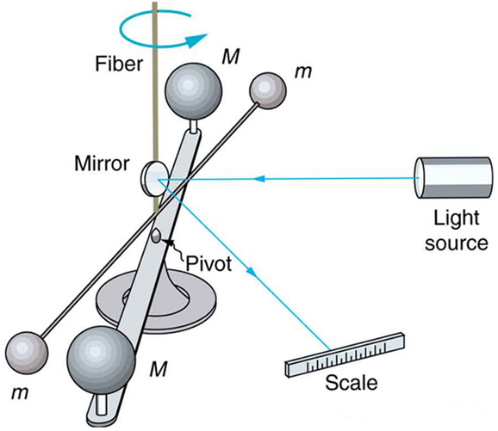
He also knew that the mass of the Earth was also in direct proportionality to the gravitational force that the Earth exerted on a given mass but there existed a constant of proportionality (the Newtonian constant of gravitation) that would provide a direct conversion into the units of force (N = kgms⁻²). There were many estimates conducted to try and determine the mass of the Earth but these values were wildly varied and unreliable for Newton to advance his theories of universal gravitation any further.
$$τ_{Total}$$
R
d

Cavendish’s apparatus shown in the diagram below. Attracted by gravitational force to the large identical lead spheres, a light horizontal rod with two small identical lead spheres at its ends rotated until the torque from gravitational force equaled to the elastic restoring force from the thin torsion fiber. The experiment was so sensitive, that slightest fluctuations of air currents in the room would send the apparatus wobbling uncontrollably, so Cavendish was required to take his measurements of the deflection of the torsion fiber outside the room using a telescope and a beam of light reflected onto a precise scale.

Consider an apparatus with the following values:

M = 101.5 kg
m = 1.20 kg
R = 1.20 m
$τ_{Total}$ = 1.23 x10⁻⁵ Nm
d = 0.400 m
Angle between R and d = 90.0°

(a) Using the total torque on the rod provided, calculate the magnitude of the force produced on either end of the rod. (3 marks)

Description | Marks
$τ_{total}=2rF F= \frac{τ_{total}}{2r}$ | 1
= $\frac{1.23×10^{-5}}{2(1.20)}$ | 1
= 5.13 x10⁻⁶ N | 1
Total | 3

(b) Using the force from (a) and the values provided, calculate a magnitude for the gravitational constant. (If you could not complete (a), use F = 5.25 x10⁻⁶ N) (3 marks)

Description | Marks
Units not required
F_{G} = $\frac{Gm_{1}m_{2}}{r^{2}}$ G = $\frac{Fr^{2}}{m_{1}m_{2}}$ | 1
= $\frac{5.13×10^{-6}(0.400^{2})}{1.20 ×101.5}$ | 1
= 6.73 x10⁻⁹ | 1
Total | 3
If F= 5.25 x10⁻⁶ N, then G = 6.89 x 10⁻⁹

(c) Calculate the percentage error of the experimentally determined value to the accepted value.
(2 marks)

Description | Marks
% error = measured – accepted x100  Accepted  = 6.73 x 10⁻⁹ – 6.67 x 10⁻¹¹ x100  6.67 x 10⁻¹¹ | 1
= +9989 (+0.90 % (accept 1%) ) | 1
If G = 6.89 x 10⁻⁹, then10230( +3.3%)
Total | 2

(d) Show, by rearranging Newton’s law of universal gravitation, the S.I units of the Newtonian constant of gravitation “G”. (3 marks)

Description | Marks
$F_{g}=\frac{Gm_{1}m_{2}}{r^{2}}$ so $G=\frac{F_{g}r^{2}}{m_{1}m_{2}}$ | 1
Units = $\frac{\left[kg m{ s}^{-2}\right]{\left[m\right]}^{2}}{\left[kg\right]\left[kg\right]}$ | 1
= [m³ kg⁻¹ s⁻²]  Accept N m² kg⁻² 3 marks | 1
Total | 3

(e) Calculate the new total torque produced with the addition of the Coulombic force.
(5 marks)

Description | Marks
F_{E} = $\frac{1}{4πε}.\frac{q1q2}{r^{2}}$, F_{G} = $\frac{Gm_{1}m_{2}}{r^{2}}$ | 1
$Σ$F = $\frac{1}{4πε}.\frac{q1q2}{r^{2}}$ + $\frac{Gm_{1}m_{2}}{r^{2}}$  = $\frac{1}{4πε}.\frac{(10×10^{-9})(10×10^{-9})}{{0.33}^{2}}$ +$\frac{(6.67×10^{-11})(101.5)(1.20)}{0.33^{2}}$  = 8.331×10⁻⁶ N | 1-2
$τ_{total}=2rF$  = 2(1.2) 8.331×10⁶ N | 1
= 2.00 x10⁻⁵ N m | 1
Total | 5

(f) State and explain the effect that the charge accumulation would have on the experimental value of the gravitational constant if the scientists were not aware of the net charge.
(2 marks)

Description | Marks
G is proportional to F which is proportional to $τ_{total}$ | 1
Increasing $τ_{total}$ would provide a larger value for the gravitational constant. | 1
Total | 2

End of questions

